
TEST PLAN

ORANGE HRM

WEB APPLICATION

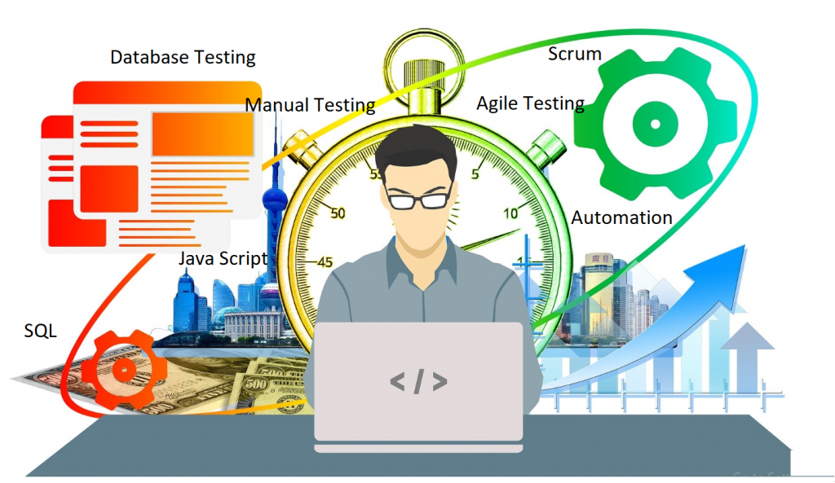

DESIGNED BY
Fachrurozi Alwi
03 Juli 2026

PREPARED BY
Fachrurozi Alwi
03 Juli 2026

OrangeHRM Web Application

Scope of Test: Login, Admin and PIM

Items | Details
Document Type | QA Test Plan
Application | OrangeHRM Web Application
Modules in Scope | Login, Admin, PIM (Personnel Information Management)
Testing Level | System / Functional Testing
Primary Testing | Functional, Negative, Positive, Regression, Smoke, Sanity, Exploratory
Prepared By | Fachrurozi Alwi
Version | 1.1
Status | Draft / Ready For Test Execution

1. DOCUMENT CONTROL

Version | Date | Author | Change Description
1.1 | 03/07/2026 | Fachrurozi Alwi | Inital Test Plan for Login, Admin and PIM

2. TEST PLAN OVERVIEW
Dokumen ini mendefinisikan pendekatan, strategi, ruang lingkup, serta proses pengujian yang akan dilakukan untuk memastikan bahwa fitur Login, Admin, dan PIM (Personnel Information Management) pada aplikasi open source OrangeHRM Web dapat berfungsi sesuai dengan kebutuhan dan spesifikasi fungsional yang telah ditetapkan.
Pengujian mencakup verifikasi terhadap fungsi utama pada masing-masing fitur, validasi input yang valid maupun tidak valid, pengujian terhadap mandatory field dan validation rule, penanganan error dan validation message, serta verifikasi hak akses dan kontrol akses berdasarkan role pengguna. Selain itu, pengujian juga dilakukan untuk memastikan bahwa perubahan atau penambahan fitur tidak menyebabkan gangguan terhadap fungsi yang sebelumnya telah berjalan dengan baik melalui proses regression testing.
Test Plan ini digunakan sebagai acuan utama dalam pelaksanaan aktivitas pengujian, mulai dari tahap perencanaan dan penyusunan test case, test data preparation, test execution, defect/bug reporting, retesting, regression testing, hingga penyusunan test summary report dan dokumentasi hasil pengujian.
Dengan adanya Test Plan ini, proses pengujian diharapkan dapat dilakukan secara terstruktur, konsisten, terukur, dan terdokumentasi, sehingga setiap fitur yang diuji dapat diverifikasi berdasarkan kriteria yang telah ditentukan dan hasil pengujian dapat digunakan sebagai dasar dalam mengevaluasi kualitas serta kesiapan aplikasi OrangeHRM Web.

3. TEST OBJECTIVES
- Memastikan admin/user dapat login dan logout pada web OrangeHRM sesuai kredensial yang valid.
- Memastikan sistem menolak kredensial tidak valid dan input yang tidak memenuhi validasi.
- Memastikan akses menu Admin sesuai role/permission user.
- Memastikan fungsi User Management dan konfigurasi Admin berjalan sesuai kebutuhan.
- Memastikan fungsi PIM untuk employee record dapat digunakan untuk create, read, update, search, dan operasi terkait.
- Memverifikasi validasi field, boundary value, mandatory field, format data, dan duplicate data.
- Memastikan perubahan data tersimpan dengan benar dan dapat ditampilkan kembali.
- Memastikan fungsi utama tidak rusak setelah perubahan atau perbaikan defect.

4. SCOPE OF TEST

Feature | In Scope | Testing Focus
Login | Username, Password, Login, Logout, validation, session | Positive, negative, validation, security-oriented checks, usability
Admin | User Management, Job, Organization, Qualifications, Nationalities, Corporate Branding, Configuration | CRUD, navigation, validation, authorization, search/filter
PIM | Employee List, Add Employee, Employee Details, Personal Details, Job, Contact Details, Emergency Contacts, Dependents, Immigration, Qualifications, Memberships, search/filter | CRUD, validation, data persistence, navigation, authorization

5. FEATURE TO BE TESTED
5.1 Login
- Login dengan username dan password valid.
- Login dengan username/password salah.
- Field kosong, whitespace, dan kombinasi input tidak valid.
- Visibility/toggle password.
- Logout dan session termination.
- Redirect setelah login dan akses halaman terproteksi.
- Handling refresh/back setelah logout
5.2 Admin
- Navigasi header/menu Admin.
- User Management: list, search, add, edit, delete.
- Job: Job Titles, Pay Grades, Employment Status, Job Categories.
- Organization: Locations, General Information, Structure.
- Qualifications: Skills, Education, Licenses, Languages, Memberships.
- Nationalities management.
- Corporate Branding.
- Configuration dan menu/setting yang tersedia pada versi aplikasi yang diuji.
- Role/permission enforcement.
5.3 PIM (Personnel Information Management)
- Employee List dan pencarian.
- Add Employee dan mandatory fields.
- Employee Details / Personal Details.
- Contact Details.
- Emergency Contacts.
- Dependents.
- Immigration.
- Job.
- Salary dan Tax/Direct Deposit.
- Qualifications, Memberships, Skills, Education, Licenses, Languages.
- Edit, save, delete and persistence data.
- Validasi format dan duplicate/invalid data.

6. FEATURE NOT IN SCOPE
- Performance/load/stress testing formal.
- Penetration testing dan security assessment formal.
- Compatibility terhadap seluruh kombinasi browser/device di luar environment yang ditetapkan.
- Infrastructure/database testing secara langsung.
- Third-party integration testing yang tidak terkait langsung dengan tiga module dalam scope.

7. TEST STRATEGY

Testing Type | Purpose | Application
Smoke | Memastikan build cukup stabil untuk pengujian lanjutan. | Login + akses Admin/PIM
Functional | Memverifikasi fungsi sesuai expected behavior. | Semua fitur in scope
Positive | Memastikan input valid menghasilkan proses yang benar. | Login, CRUD Admin/PIM
Negative | Memastikan input invalid ditolak dengan benar. | Validation, invalid credentials, invalid formats
Boundary | Menguji nilai minimum/maksimum/batas field. | Field text, numeric, date, ID
Equivalence Partitioning | Menguji representative valid/invalid classes. | Username, email, date, dropdown
Exploratory | Menemukan defect di luar scripted test. | Navigasi, edge cases, UI behavior
Regression | Memastikan perubahan tidak merusak fungsi existing. | Login + Admin + PIM
Sanity | Validasi cepat setelah perubahan kecil/fix. | Area yang berubah + dependency
Authorization | Memastikan role hanya dapat mengakses fungsi yang diizinkan. | Admin/PIM

8. TEST ENVIRONMENT

Component | Recommended Setup
Application | OrangeHRM Web Application / test instance
Operating System (OS) | Windows 11 64bit
Browser | Google Chrome, Mozilla Firefox, Microsoft Edge
Devices | Asus TUF Notebook
Test Tools | Browser DevTools, Google Spreadsheet, Postman, and GIT
Defect Tracking | Trello, Spreadsheet

9. TEST DATA

Data Category | Example / Role
Admin User | User dengan role yang memiliki akses Admin.
ESS User | User dengan permission terbatas untuk authorization testing.
Invalid Credentials | Username salah & Password benar. Username benar & Password salah, atau keduanya salah.
Employee Data | Nama, Employee ID, DOB, gender, contact, job, education, skills, dll.
Boundary Data | Minimum/maximum length, angka batas, date boundary, empty/whitespace
Duplicate Data | Employee ID / username / email
Specials Characters | Input dengan karakter khusus dan unicode

10. ENTRY CRITERIA & EXIT CRITERIA
ENTRY CRITERIA
- Requirement Login, Admin, dan PIM telah tersedia dan disetujui.
- Test environment OrangeHRM telah siap dan dapat diakses.
- Test data dan akun pengujian telah tersedia.
- Test scenario dan test case telah dibuat dan direview.
- Build aplikasi yang akan diuji telah tersedia dan dapat digunakan.
EXIT CRITERIA
- Seluruh test case Login, Admin, dan PIM telah dieksekusi.
- Tidak terdapat Critical/Blocker defect yang masih terbuka.
- Minimal 95% test case berstatus Pass.
- Regression dan retesting terhadap defect telah selesai.
- Test report dan hasil testing telah selesai didokumentasikan.

11. TEST DELIVERABLES
- Test Plan Document
- Test Scenario & Test Case
- Test Data
- Defect/Bug Report
- Evidence / Screenshot
- Test Execution Report / Test Summary Report

12. ROLES & RESPONSIBILITIES

ROLES | RESPONSIBILITIES
QA Engineer (Fachrurozi Alwi) | • Analyze requirements and design test scenarios & cases.  • Execute tests, perform debugging, and log defects.  • Conduct API testing using Postman to validate requests and responses, status codes, response bodies, and ensure that the APIs function according to the requirements.  • Generate reports and track test progress.
Mentor (M. Abdul Aziz) | • Review test scenarios, test cases, and test execution results to ensure adequate test coverage and identify potential defects.  • Provide guidance on testing best practices.  • Evaluate documentation and overall testing quality.

12. USER ACCEPTANCE CRITERIA
Login Feature :

Scenario ID | Scenario Name | Type | Expected Result
TS-Login-001 | Input valid email and password | Positive | User navigate to dashboard OrangeHRM Page
TS-Login-002 | Input invalid email or password | Negative | Toast message "Invalid Credentials" appears and user can not login
TS-Login-003 | Input with empty email | Negative | Toast message "Invalid Credentials" appears and user can not login
TS-Login-004 | Input with empty password | Negative | Toast message "Invalid Credentials" appears and user can not login

Admin Feature :

Scenario ID | Scenario Name | Type | Expected Result
TS-Admin-001 | Search user by username | Positive | The system shows the user matching by username.
TS-Admin-002 | Search user by user role | Positive | The system shows the user matching by user role.
TS-Admin-003 | Search user by employee name | Positive | The system shows the user matching by employee name.
TS-Admin-004 | Search user by status | Positive | The system shows the user matching by status.
TS-Admin-005 | Search user by not registered | Negative | Toast message “No records found”
TS-Admin-006 | Add user by valid data | Positive | User account is created and success message appears
TS-Admin-007 | Add user by duplicate data | Negative | Toast message “User already exists”
TS-Admin-008 | Edit User | Positive | The user is successfully updated.
TS-Admin-009 | Delete User | Positive | The user is successfully deleted.

PIM Feature :

Scenario ID | Scenario Name | Type | Expected Result
TS-PIM-001 | Search employee with valid data | Positive | The system successfully shows the employee record that matches the entered valid search criteria.
TS-PIM-002 | Search employee with invalid data | Negative | The system shows toast message “No Records Found”
TS-PIM-003 | Add employee with valid data | Positive | Employee is successfully added and displayed in the Employee List.
TS-PIM-004 | Add employee with invalid data | Negative | Employee is not added, and a validation message is displayed
TS-PIM-005 | Add employee with empty field | Negative | Employee is not added, toast message “Required a Field”
TS-PIM-006 | Edit employee | Positive | The system displayed Employee is successfully updated
TS-PIM-007 | Delete Employee | Positive | The system displayed Employee is successfully deleted.

